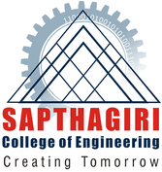
SAPTHAGIRI COLLEGE OF ENGINEERING
#14/5, Chikkasandra, Hesaraghatta Main Road, Banglore-560057, Karnataka, India DEPARTMENT OF MECHANICAL ENGINEERING

FACULTY PROFILE
Name of the faculty

MAHESH S

Designation

ASSISTANT PROFESSOR
Contact Number

8050303235
Email ID

maheshs@sapthagiri.edu.in

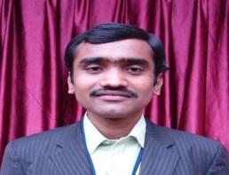Educational Qualification
Degree | Specialization | University | Year of Passing
M.Tech | Manufacturing Science &  Engineering | VTU | 2015
B.E | Mechanical Engineering | VTU | 2012

Work Experience

Teaching | Research | Industry
3.5 | --- | 2

Publications

National/International Journals | National/International Conferences | Books Authored/Edited
1 | --- | ---

Area of Interest

Composite Materials
Manufacturing process
Quality

Membership in Professional Bodies/University Bodies/Organization
- International Association of Engineers (IAENG)

Publications National/International Journals

- BirajDhibar, SiddarthVikram Singh, Shoed Anwar, Abhineet Singh, Mahesh S, T Venkategowda , “Sugarcane Bagasse Reinforced Polymer Composites”, International Journal of Engineering Research & Technology (IJERT), ISSN:2395-0056.
Patents/Funds
Nil

