**FACULTY PROFILE**

|  |  |  |
| --- | --- | --- |
| National/International Journals | National/International Conferences | Books Authored/Edited |
| 1 | 2 | 0 |

|  |  |
| --- | --- |
| Name of the faculty | Mrs. RAMYA M |
| Designation | ASSISTANT PROFESSOR |
| Contact Number | 9035344998 |
| Email ID | ramyam@sapthagiri.edu.in |

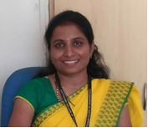 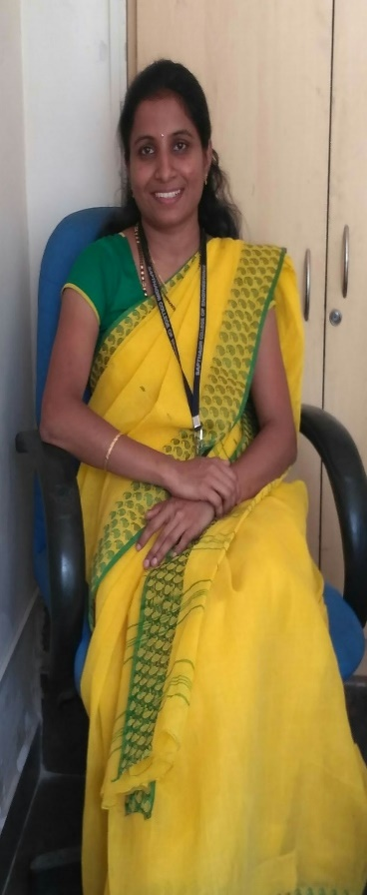

**Educational Qualification**

|  |  |  |  |
| --- | --- | --- | --- |
| Degree | Specialization | University | Year of Passing |
| Ph.D | High Voltage Engineering | VTU | Pursuing |
| M.Tech | VLSI Design & Embedded System | VTU | 2011 |
| B.E | Electrical & Electronics Engineering | VTU | 2008 |

**Work Experience**

|  |  |  |
| --- | --- | --- |
| **Teaching** | **Research** | **Industry** |
| 8 | 0 | 1 |

**Publications**

**Area of Interest**

|  |  |
| --- | --- |
| Microcontroller | VLSI Design |
| High Voltage Engineering | **Control System** |

**Subject Taught**

|  |  |  |
| --- | --- | --- |
| Basic Electrical | Microcontroller | Logic Design |
| Control System | Digital System Design |  |
| Transmission and Distribution | Electronics Communication System |  |
| Power Generation and Economics | Energy Auditing and Demand Side Management |  |

**In House Experience**

|  |  |  |  |
| --- | --- | --- | --- |
| **Sl. No** | **Designation** | **Period** | |
| **From** | **To** |
| **1** | **Assistant Professor** | **27/02/2012** | **Till Date** |

**Publications National/International Journals**

1. Mrs. Ramya M; Dr.Dinesh M N, “ Study on the Source Characteristics of HVDC set for Pollution Test”, International Journal of Scientific Research and Review, May 2019 volume 8 issue 5, ISSN No.2279-543X.

**National /International Conferences**

1. Mrs. Ramya M; Dr.Dinesh M N, “Experimental study of source characteristics for pollution test”, National

conference on Power and Energy Systems-18,, At Kalasalingam University, April 12 – April 13, 2018.

1. Mrs. Ramya M; Dr.Dinesh M N, “Experimental study of source characteristics for pollution test for DC source”,

International conference on High Voltage Engineering and Technology-18,, At CPRI, Hyderbad, Feb 07 – Feb 08, 2019.

* Two days Faculty Development Program on “Computer Aided Electrical Drawing” conducted by Sapthagiri College of Engineering from 31-02-2013 & 02-02-2013.
* One day Faculty Development Program conducted by Sapthagiri College of Engineering on 22-01-2015
* Three days Faculty Development Program on “Teacher Empowerment” conducted by Sapthagiri College of Engineering from 23-07-2018 to 25-07-2018.

**Faculty Development Programme Participated**

* Five days Workshop on “Potential Research Avenues and Emerging Technologies in the field of Electrical Engineering” organized by Reva Institute of Technology and Management” on march 2012.
* Two days Workshop on “Recent Advances in Power System” organized by Sapthagiri College of Engineering from 24-07-2012 to 25-07-2012.
* Two days Workshop on “Essence of Research works on Pollution Performance of Insulator and Arrestors” organized by Sapthagiri College of Engineering from 24-01-2014 to 25-01-2014.
* Two days Workshop on “Insulated Power Cables and Insulation” organized by RV College of Engineering from 16-10-2017 to 17-10-2017.
* One Day National Workshop on “High Voltage Insulator Manufacturing Technique and Testing” organized by National Power Training Institute on 30th January,2019.

**Workshop Attended**