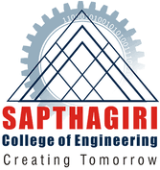
SAPTHAGIRI COLLEGE OF ENGINEERING
Publications
Area of Interest
#14/5, Chikkasandra, Hesaraghatta Main Road, Banglore-560057, Karnataka, India DEPARTMENT OF COMPUTER SCIENCE & ENGINEERING

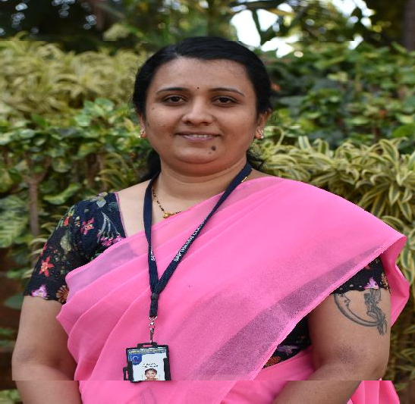FACULTY PROFILE
b
Name of the faculty

BHAVYA N P

Designation
ASSISTANT PROFESSOR
Contact Number
9845750315
Email ID
bhavyanp@sathagiri.edu.in

Educational Qualification

Degree | Specialization | University | Year of Passing
Ph.D | Fluid Mechanics | VTU | Pursuing
M.Sc | Fluid Mechanics | Bangalore University | 2006
B.Sc | PMCs | Bangalore University | 2004

Work Experience

Teaching | Research | Industry
12 | 0 | 0

National/International Journals | National/International Conferences | Books Authored/Edited
0 | 0 | 0

Fluid Mechanics
Graph Theory
Mathematical Modeling
Magneto Hydrodynamics

List of Funded Projects
Membership in Professional Bodies/University Bodies/Organization

Patent

•

National /International Conferences
Publications National/International Journals
. “The Effect of wall absorption on dispersion in an annular flow of Couple Stress Fluid”- International Conference on Mathematical Modelling (23rd -24th December 2016) conducted at Don Bosco Institute of Technology.

Faculty Development Programme Participated

- Attended one day Faculty Development Program on 22/01/2015 at Sapthagiri College of Engineering, Bengaluru

- Attended three days Faculty Development Program on “Teacher Empowerment” at Sapthagiri College of Engineering during 23rd to 25th July 2018.
L

- Attended five days Faculty Development Program on “Applications of Mathematics in Engineering & Technology”, at Acharya Institute of Technology during 3rd to 7th February 2020.

