SRI SRINIVASA EDUCATIONAL AND CHARITABLE TRUST
SAPTHAGIRI COLLEGE OF ENGINEERING, BANGALORE-560057
(Affiliated to Visvesvaraya Technological University, Belgaum, Approved by AICTE, New Delhi)
14/5, Chikkasandra, Hesaraghatta Main Road
Bengaluru – 560 057

Department of Electrical and Electronics Engineering
REPORT ON:
Hands on training “EMBEDDED SYSTEMS”
05/10/2019-6/10/2019
By
Mr.Rakshit
M/s Ti2 technology,Bangaluru

SRI SRINIVASA EDUCATIONAL AND CHARITABLE TRUST
SAPTHAGIRI COLLEGE OF ENGINEERING, BANGALORE-560057
(Affiliated to Visvesvaraya Technological University, Belgaum, Approved by AICTE, New Delhi)
14/5, Chikkasandra, Hesaraghatta Main Road
Bengaluru – 560 057

Report:
Department of Electrical and Electronics hadarranged anhands on session on “Embedded systems and Power Electronics” to the students of 7thsem ‘A&B’ sections.Mr.Rakshit, Proprietor, M/s Ti2 technology,Bengaluru and Alumni of Sapthagiri college of Engineering, Gave a thorough training to the students on embedded systems and power electronics. This will help the students to carry out projects using Embedded Systems and Power Electronics.
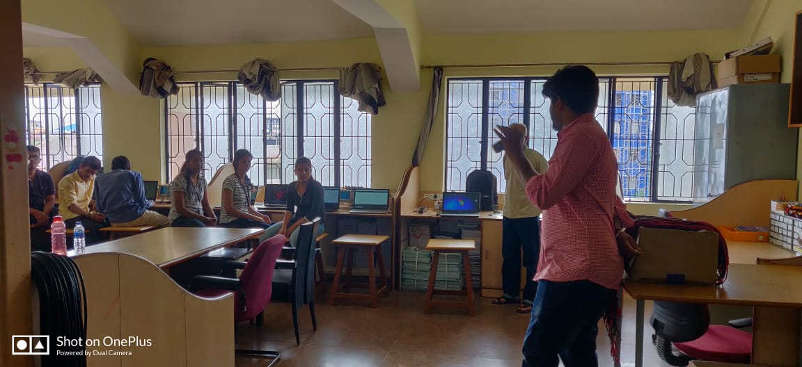
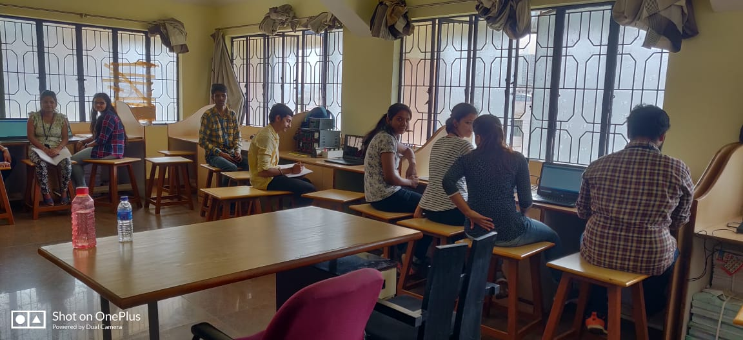
Students during hands on session
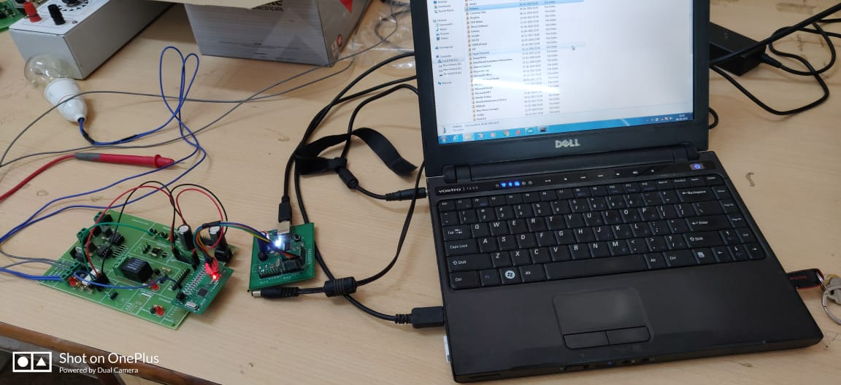
Equipment’s used for training

(Alumni coordinator) EEE HOD

