**FACULTY PROFILE**

|  |  |  |
| --- | --- | --- |
| **Teaching** | **Research** | **Industry** |
| 4.5 | - | - |

**Work Experience**

|  |  |  |  |
| --- | --- | --- | --- |
| Degree | Specialization | University | Year of Passing |
| M.Tech | Energy Systems & Management | JSS Science and Technology University, Mysuru | 2013 |
| B.E | Electrical & Electronics Engineering | JNTU | 2009 |

**Educational Qualification**

|  |  |
| --- | --- |
| Name of the faculty | Mr. MURALI KRISHNA KANDARI |
| Designation | ASSISTANT PROFESSOR |
| Contact Number | 9844066828 |
| Email ID | muralikrishna@sapthagiri.edu.in |

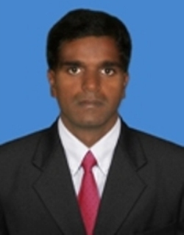

**Area of Interest**

|  |
| --- |
| POWER SYSTEMS |
| POWER ELECTRONICS |

**Funded Projects**

**Patents**

**Faculty Development Programme Participated**

* Faculty Development Program conducted by SCE, Bengaluru on Teacher Empowerment

1. Book on Energy aware routing protocol for WSN
2. Reviewer for Elsevier Journal

**Awards/Recognition/Achievement/Others**

1. Workshop on NS3 organized by Acharya Institute of Technology

**Workshop Attended**