**FACULTY PROFILE**

|  |  |
| --- | --- |
| Inorganic Chemistry, Adsorption |  |
|  |  |
|  |  |
|  |  |

**Area of Interest**

|  |  |  |
| --- | --- | --- |
| National/International Journals | National/International Conferences | Books Authored/Edited |
|  |  |  |

**Publications**

|  |  |  |
| --- | --- | --- |
| **Teaching** | **Research** | **Industry** |
| 19 |  |  |

**Work Experience**

|  |  |  |  |
| --- | --- | --- | --- |
| Degree | Specialization | University | Year of Passing |
| M Sc | Inorganic Chemistry | Bangalore University | 2000 |
| M Phill | Adsorption | Periyar University | 2009 |
|  |  |  |  |

**Educational Qualification**

|  |  |
| --- | --- |
| Name of the faculty | RaviKantha N |
| Designation | **Asst Professor** |
| Contact Number | **7019184349** |
| Email ID | **ravikanthan@sapthagiri.edu.in** |

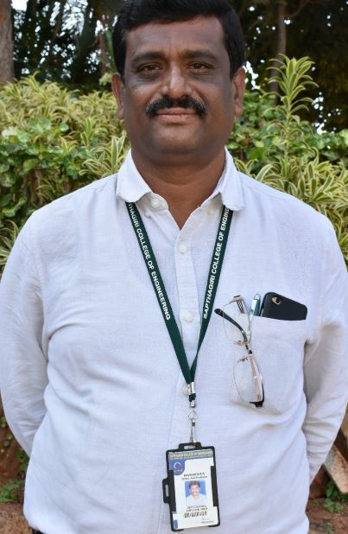

**Publications**

**Outside Experience**

|  |  |  |  |
| --- | --- | --- | --- |
| **Sl.No** | **Designation** | **Period** | |
|  |  | **From** | **To** |
| **1** | **Asst Professor** | **November 2004** | **August 2010** |
| **2** | **Asst Professor** | **02.04.2015** | **Till date** |

**In House Experience**

|  |  |  |
| --- | --- | --- |
| **Subject** | **Subject code** | **Number of times taught** |
| **Engg. Chemistry** | **18CHE12/17CHE12/15CHE12/14CHE12/10CHE12/06CHE12** | **38** |
| **Engg. Chemistry Lab** | **18CHEL16/17CHEL17/15CHEL17/14CHEL17/10CHEL17/06CHEL17** | **38** |
|  |  |  |
|  |  |  |

**Subject Taught**

|  |  |  |  |  |
| --- | --- | --- | --- | --- |
| **Sl. No** | **Place of Work** | **Designation** | **Period** | |
|  |  |  | **From** | **To** |
| 1 | Alpha College of Engineering | Lecturer | October 2001 | September 2002 |
| 2 | East west Institute of Technology | Lecturer | September 2002 | September 2004 |
| 3 | Shashib College of Engineering | Asst Professor | August 2010 | March 2015 |

**Membership in Professional Bodies/University Bodies/Organization**

* **Panel member for Board of Examiner Adichunchanagiri University**

**National/International Journals**

**Awards/Recognition/Achievement/Others**

**Workshop Attended**

Workshop on model Curriculum at BIT, Bangalore, in the year 2017

**Faculty Development Programme Participated**

Fac

**National /International Conferences**