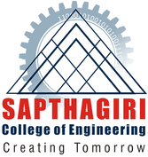
SAPTHAGIRI COLLEGE OF ENGINEERING
Degree | Specialization | University | Year of Passing
M.Tech | Mechanical Engineering | VTU | 2008
B.E | Mechanical Engineering | BU | 2002

#14/5, Chikkasandra, Hesaraghatta Main Road, Banglore-560057, Karnataka, India DEPARTMENT OF MECHANCIAL ENGINEERING

FACULTY PROFILE
 |  | 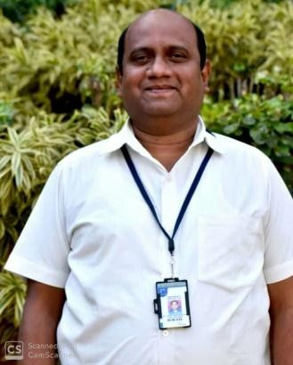
Name of the faculty | Padmanabha G
Designation | Assistant Professor
Contact Number | 9886888581
Email ID | padmanabhag@sapthagiri.edu.in

Teaching | Research | Industry
14 | 2 | 2

Publications
Educational Qualification
Work Experience

National/International Journals | National/International Conferences | Books Authored/Edited
- | - | -

Area of Interest

Thermodynamics | Heat Transfer
I C Engine | Power Plant Engineering

Subjects Taught
Basic Thermodynamics | Turbomachines | Heat Transfer
Non Conventional Energy Sources | Biomass Energy Systems | Computer Aided Engineering Drawing
Elements of Mechanical Engineering | Energy Engineering | Automobile Engineering
Power Plant Engineering

FACULTY DEVELEOPMENT PROGRAM PARTICIPATED
- “Advanced Materials and Materials Processing” on 8th -13th June 2009 organized by Siddaganga Institute of Technology Bangalore (6 Days)
- “Non Linear Finite element Analysis using LS-DYNA” on 5th -9th March 2012 organized by Channabasaveshwara Institute of Technology Gubbi (5 Days)
- “MISSION 10X” on 30th Jan- 3rd Feb 2012 organized by Sapthagiri college of engineering Bangalore (5 Days)

FUNDS/Patents
NIL

Awards/Recognition/Achievement/Others
- Padmanabha G, Kushal S, Manjunatha M, Prathik S and raghava Surya, “Power generation using engine exhaust gas for air brake system” funded 7000.00 (Seven Thousand only) by Karnataka State council for Science and Technology KSCST, student project in the year2018-19.
Workshop attended
  - Workshop on “Energy conservation, its need in the present, Time and Methods of conservation” on 23rd -24th
April 2010 Conducted by ShirdiSai Engineering College Bangalore (2 Days)
  - Workshop on “Recent Advances in refrigeration and Air conditioning”, on 28th -29th August 2009 conducted by Nagarjuna College of Engineering and Technology Bangalore (2 Days)
  - Workshop on “Intensive Training in practical counseling skills”, 17th January 2020 conducted by Sapthagiri college of engineering Bangalore (1 day)

