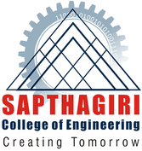
SAPTHAGIRI COLLEGE OF ENGINEERING
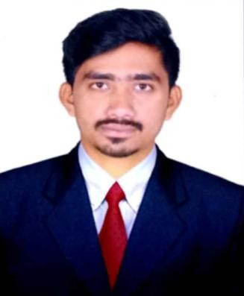#14/5, Chikkasandra, Hesaraghatta Main Road, Banglore-560057, Karnataka, India DEPARTMENT OF MECHANICAL ENGINEERING

 | FACULTY PROFILE
 | Name of the faculty | SATISH KUMAR Y D
 | Designation | ASSISTANT PROFESSOR
 | Contact Number | 8147777010
 | Email ID | satishkumaryd010@gmail.com

Educational Qualification
 | Degree | Specialization | University | Year of Passing
 | M.Tech | Industrial Engineering &  Management | VTU | 2017
 | B.E | Mechanical Engineering | VTU | 2015

Work Experience

Teaching | Research | Industry
2 | - | -

Publications

National/International Journals | National/International Conferences | Books Reviewed
- | - | -

Area of Interest

Total Quality Management | Thermal Engineering
Lean Management | Research & Development
Continuous Improvement | Manufacturing Science
Hydraulics & Pneumatics

Subject Taught
Publications National/International Journals

Strength of Materials | Industrial Management | Fluid Power Engineering
Hydraulics & Pneumatics | Automobile Engineering
Entrepreneurship & Management | Automotive Mechanics
Basic Thermal Engineering | CAMD

NATIONAL /INTERNATIONAL CONFERENCES

1) Active participant of 1st International conference held by East West Institute of Technology ICETEM ( International Conference on Emerging Trends in Engineering & Management )

Workshop Attended

Faculty Development Programme Participated Awards/Recognition/Achievement/Others

- Qualified for Assistant Professor through UGC-NET December 2018
- Organized Industrial visits & In plant Training for the department students to SML-ISUZU (2019)

