**FACULTY PROFILE**

|  |  |
| --- | --- |
| Name of the faculty | Mrs. ASHWINI C |
| Designation | ASSISTANT PROFESSOR |
| Contact Number | 9620960502 |
| Email ID | [ashwinic@sapthagiri.edu.in](mailto:ashwinic@sapthagiri.edu.in) |

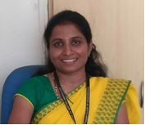 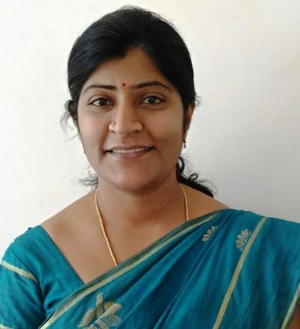

**Educational Qualification**

|  |  |  |  |
| --- | --- | --- | --- |
| Degree | Specialization | University | Year of Passing |
| M. Tech | Power System Engineering | VTU | 2011 |
| B.E | Electrical & Electronics Engineering | VTU | 2009 |

**Work Experience**

|  |  |  |
| --- | --- | --- |
| **Teaching** | **Research** | **Industry** |
| 8.5 | 0 | 0 |

**Area of Interest**

|  |  |
| --- | --- |
| Power System | Digital Electronics |
| Machines | **Control System** |

**Subject Taught**

|  |  |  |
| --- | --- | --- |
| Basic Electrical | Transformers and Generators | Estimation and Costing |
| Control System | Digital System Design | Power System Analysis |
| Transmission and Distribution | Switch Gear Protection | Management and Entrepreneurship |
| Power Generation and Economics | Electric Motors |  |

**In House Experience**

|  |  |  |  |
| --- | --- | --- | --- |
| **Sl. No** | **Designation** | **Period** | |
| **From** | **To** |
| **1** | **Assistant Professor** | **01/07/2011** | **Till Date** |

**Faculty Development Programme Participated**

**Workshop Attended**

* Two days Faculty Development Program on “Computer Aided Electrical Drawing” conducted by Sapthagiri College of Engineering from 31-02-2013 & 02-02-2013.
* Three days Faculty Development Program on “Computer Aided Electrical Drawing” conducted by RNSIT from 22-01-2013 to 24-01-2013.
* Three days Faculty Development Program on “Teacher Empowerment” conducted by Sapthagiri College of Engineering from 23-07-2018 to 25-07-2018.
* One day Faculty Development Program conducted by Sapthagiri College of Engineering on 22-01-2015

1. Three Days Workshop on “Digital Signal Processing Lab” organized by Acharya Institute of Technology from 29-01-2018 to 31-01-2018.
2. Two days Workshop on “ Recent Developments in Solar Power Generation” organized by M S Engineering college from 25-07-2013 to 26-07-2013.
3. Two days Workshop on “ Recent Advances in Power System” organized by Sapthagiri College of Engineering from 24-07-2012 to 25-07-2012.
4. Two days Workshop on “Essence of Research works on Pollution Performance of Insulator and Arrestors” organized by Sapthagiri College of Engineering from 24-01-2014 to 25-01-2014.
5. Three Days Workshop on “Recent Trends in Power System” organized by RV College of Engineering.

L