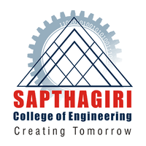 | SRI SRINIVASA EDUCATIONAL AND CHARITABLE TRUST  SAPTHAGIRI COLLEGE OF ENGINEERING, BANGALORE-560057  (Affiliated to Visvesvaraya Technological University, Belgaum, Approved by AICTE, New Delhi)  14/5, Chikkasandra, Hesaraghatta Main Road  Bengaluru – 560 057
Table 1

Department of Electrical and Electronics Engineering
REPORT ON:
Technical Talk “Introduction of Machine Learning”
on
05/10/2019
By
Sumit N
Alumni of EEE Dept

SRI SRINIVASA EDUCATIONAL AND CHARITABLE TRUST
SAPTHAGIRI COLLEGE OF ENGINEERING, BANGALORE-560057
(Affiliated to Visvesvaraya Technological University, Belgaum, Approved by AICTE, New Delhi)
14/5, Chikkasandra, Hesaraghatta Main Road
Bengaluru – 560 057
Table 2

Report:
Department of Electrical and Electronics has arranged an technical talk on “Electric Vehicles” to the students of 5th sem ‘A&B’ sections Sumit N Alumni of EEE Dept. The session was very interactive, where he explained the outcome and necessity about Machine Learning and its importance towards the upcoming generations.. Development of research activites in Machine learning was also explained.
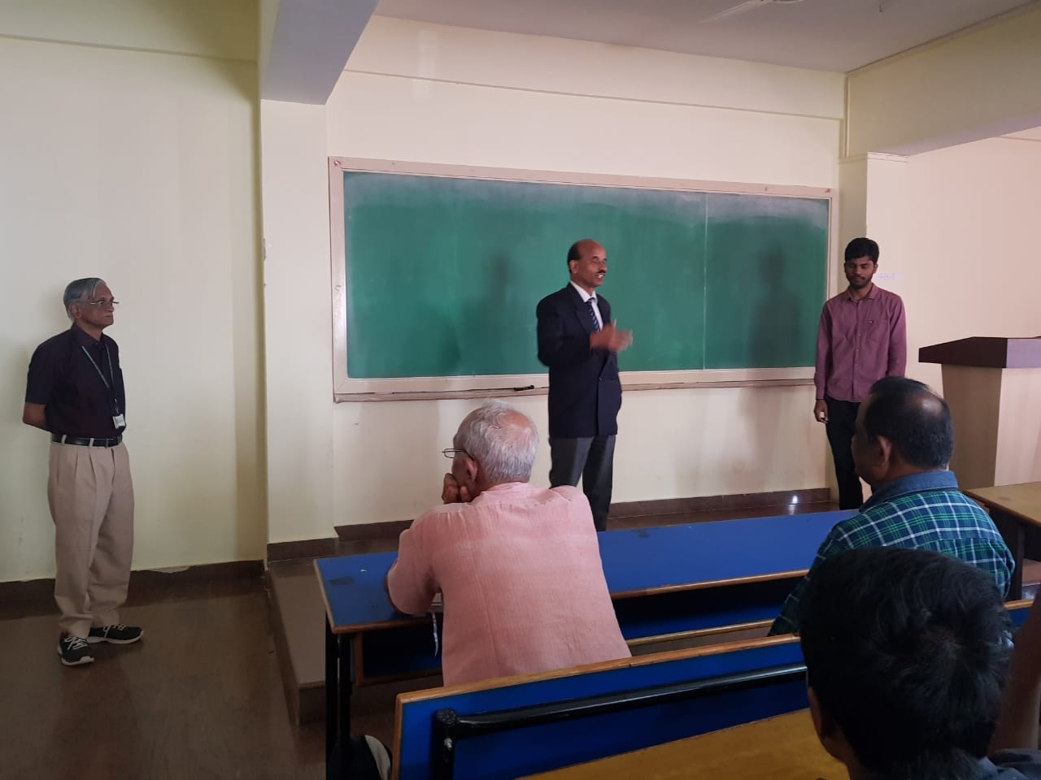
Principle addressing the faculty and students prior to technical talk

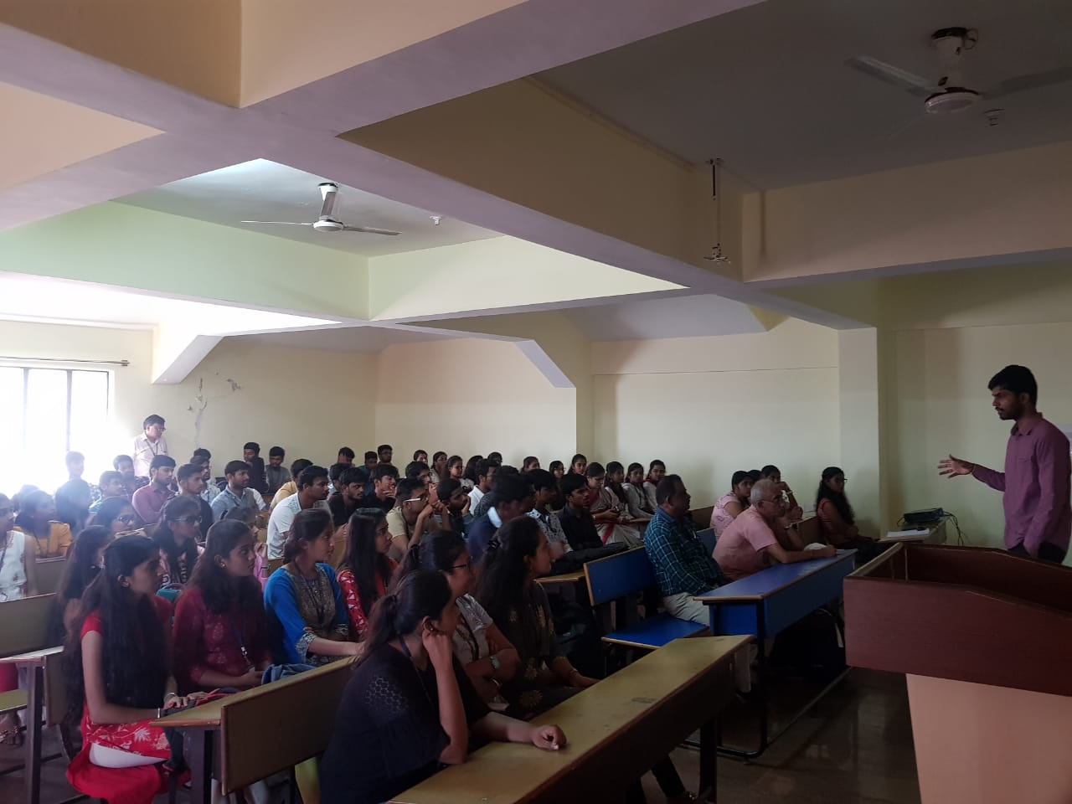

Mr. Summit delivering the talk

Principal Dr.K.N.Ravi
Head of the Department

