SAPTHAGIRI COLLEGE OF ENGINEERING
#14/5, Chikkasandra, Hesaraghatta Main Road, Banglore-560057, Karnataka, India DEPARTMENT OF MECHANICAL ENGINEERING

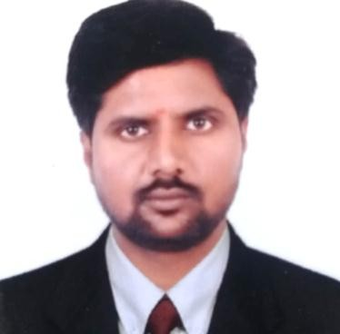FACULTY PROFILE
Name of the faculty

RAMESH N G

Designation

ASISTANT PROFESSOR

Email ID

rameshng@sapthagiri.edu.in

Educational Qualification

8884408004
Contact Number

Degree | Specialization | University | Year of Passing
Pursuing (Ph.D) | Composite Materials | VTU | ---
M.Tech | Aeronautical Engineering | VTU | 2011
B.E | Mechanical Engineering | VTU | 2009
Work Experience

Teaching | Research | Industry
8 | --- | ---

Publications

National/International Journals | National/International Conferences | Books Authored/Edited
2 | 2 | ---

Area of Interest

Finite Element Analysis | Composite Materials
Fluid Machines | Aircraft Structures

Membership in Professional Bodies/University Bodies/Organization

- International Association of Engineers (IAENG)
- Life time member of Teaching and Education Research Association (TERA).

Publications National/International Journals
- The paper titled “Fatigue Analysis of a Panel Consisting of Window Cutout and Frames in the Fuselage of a Transport Airframe’’ has been published in International research journal of engineering and technology(IRJET), vol-3, issue 4.
- The paper titled “Finite Element Analysis of a Diesel Engine Connecting Rod’’ has been published in Journal International Journal of Engineering Science & Research and Technology (IJESRT), vol3, issue 6.

NIL
National /International Conferences
- Presented Paper titled “Fatigue Analysis of a Diesel Engine Connecting Rod” in the National conference held on 13th & 14th August 2013, organized by Vemana Institute of Technology, Bangalore.
- Participated National convention of Aerospace Engineer held on 26th & 27th November 2009 organized by the Institute of Engineers (India), Bangalore.

Faculty Development Programme Participated
L

Funds/Patents

Awards/Recognition/Achievement/Others
- M Tech in Aeronautical Engineering Completed in 2011 and secured VTU 2nd Rank.

