DEPARTMENT OF MECHANICAL ENGINEERING

ROYAL BEATS

TOWARDS NEW DIMENSION

SAPTHAGIRI COLLEGE OF ENGINEERING

#14/5, HESRAGHATTA MAIN ROAD, CHIKKASANDRA, JALAHALLII WEST, BENGALURU -560057

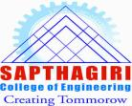

**VISION**

To create academically excellent and globally competent Mechanical professionals with ethical and human value.

**MISSION**

To impact quality technical education to build strong foundation in Mechanical Engineering domain with industry training and research by including team spirit and leadership qualities to support technological development and innovation in global environment

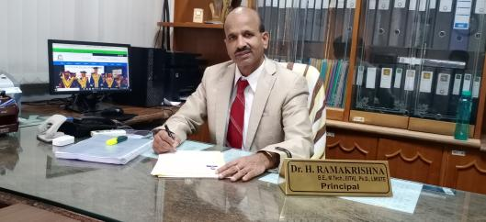

**PRINCIPALS’ MESSAGE**

It gives me immense pleasure to note that, SCE has been publishing bi-annual newsletter and I am sure, this will provide an opportunity for the faculty and students to share their knowledge and beacon the information about various issues and activities that are being taking place in the department. I look forward for more activities and achievements for the department to march towards excellence in the future. I would like to thank all teaching, supporting staff and our beloved students for their active participation in publishing this magazine. My special compliments and congratulation to the editorial team of the department for their consistent effort in publishing this newsletter.

**Dr. H Ramakrishna Principal**

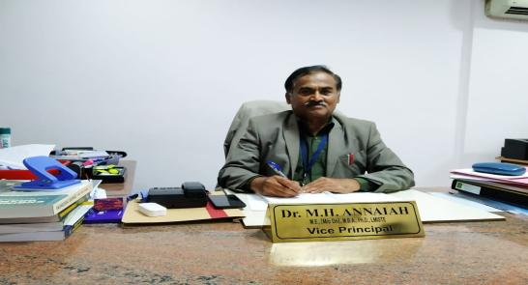

**VICE PRINCIPALS’ MESSAGE**

I am very happy and delighted to know that our college is bringing out the college newsletter. SCE is one of the leading premier engineering colleges in the country offering quality technical education to students thereby enabling them to become globally acceptable engineers in their domains. The newsletter provides a platform for both faculty and students to showcase their achievements and hidden talents. I congratulate our beloved principal and members of editorial board for bringing out this excellent and informative newsletter on time

**Dr M H Annaiah Vice-Principal**

The ROYAL BEATS is a great way to stay connected with the mechanical department. Our aim is to create a platform to exchange information on all aspects of mechanical engineering, the original articles on innovation,achivements by the faculty, students, aluminietc are invited.

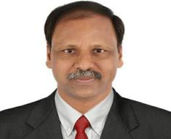

**HODS DESK**

|  |  |
| --- | --- |
| **P.hD AWARDED** | Dr.P.MahadevaSwamy |

|  |  |
| --- | --- |
|  |  |

Prof. Raghavendra.G. Deshpande has been awarded Doctor of Philosophy from Vishveswaraiah Technological University (VTU), Belgum on 18th March 2018.

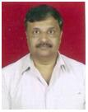

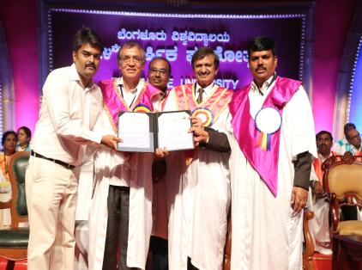

Prof.BasavarajuS has been awarded Doctor of Philosophy from the Banglore university on 22nd April 2019.

STUDENT ACHIEVEMENT

1.Students of 6th semAmbha Prasad G Hedge, Keshav A, M Amritha Nair, AkashHebbar and Dhanush L participated at the MECH EXPO 2K19 held at Sri VenkateshwaraColleg of Engineering on 18th May 2019under the guidance of Dr.Tulsidas D. The event was Sponsored by SNS Constructions.

2.Final year students Himanshu, AyanGuhaRoy,KumarRohan, Md.RehanNasim Presented a paper on the topic of “Power Generation at Speed Bumper by Pneumatic Mechanism” in the National Conference on Emerging Trends in Materials, Designs And Manufacturing under the guidance of Dr. R G Deshpande. The event was organized by the Department of Mechanical Engineering, during 17th and 18th May 2019.

3.Final year Students Himanshu, AyanGuhaRoy,KumarRohan, Md.RehanNasim published a paper titled “Power Generation at Speed Bumper by Pneumatic Mechanism” in the International Research Journals of Engineering and Technology (IJERT) under the guidance Dr. R G Deshpande , which was published in the edition of May 2019.

**PAPERPUBLICATIONS**

1. Professor Siva Murali Mohan Reddy A presented the paper on “The Effect of Porous Material on Transient Free Convection in a Concave Shaped cavity” in International Conference on Advanced Research in Mechanical Engineering during 29th& 30th April 2019, organized by Department of Mechanical Engineering held at MVL College of Engineering, Bengaluru.

2. Professor Siva Murali Mohan Reddy A presented the paper on “Numerical Investigation on Fluid Flow through Porous Media and Empirical Correlation for Pressure Drop” in the second International Conference on Emerging Trends in Science & Technologies for Engineering Systems held on 17th and 18th May 2019, held at SJC Institute of Technology, Chickballapur, Karnataka.

3. Professor Siva Murali Mohan Reddy A presented the paper on “Numerical “ in the three day International conference in “Numerical Optimization in Engineering & Sciences” organized by the Department of mathematics, National Institute of Technology, Warangal during19th to 21st June,2019.

4. Professor Dr.TulsidasD presented a paper on “Fatigue Life & Creep Life Estimation of Rotor Blade Using Ansys” in Third International Conference on Recent Research Emerging Trends in Materials and Mechanical Engineering held on 12th& 13th july,2019, held at REVA University, Bengaluru.

5. Professor Dr.RaghavendraDeshpandae presented a paper on “Implementations towards sustainable campus and smart city” in Third International Conference on Recent Research Emerging Trends in Materials and Mechanical Engineering held on 12th& 13th july,2019, held at REVA University, Bengaluru.

6.ProfessorDrMahadevaswamy P presented a paper on “Vibration control of clamped rectangular plate by dual flaps ” in Third International Conference on Recent Research Emerging Trends in Materials and Mechanical Engineering held on 12th& 13th july,2019, held at REVA University, Bengaluru.

7.Professor DrMahadevaswamy P presented a paper on “Free vibrational analysis of square plate under different boundary conditions using ANSYS and MATLAB” in Third International Conference on Recent Research Emerging Trends in Materials and Mechanical Engineering held on 12th& 13th july,2019, held at REVA University, Bengaluru.

FACULTY DEVELOPMENT PROGRAMME

1.Dr.Tulsidas S attended Faculty Development Program on “New Product Development Using Creo ”organized under the aegis of VTU in association with CADD Centre Training Service Pvt. Ltd., held at RNSIT on 3rd May 2019 at Bengaluru.

FA

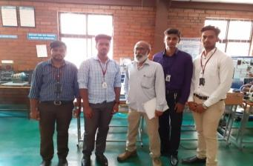

Students of 8th semRaghava Surya M, Kushal S, Manjunath M, Prateek S participated in KSCST project exhibition held at Dayanandsagar college of Enginnering, Banglore.The project titled POWER GENERATION BY ENGINE EXHAUST GAS FOR AIR BRAKE SYSTEM was guided by Padmanabha G.

KSCST PROJECTS

Students of 8th CHETAN GOWDA H S, MANISH RAO S, ROHITH J participated in KSCST State level project exhibition held at KLE Society’s Dr.M.S.Sheshagiri College of Engineering and Technology, Belagavi on 26th and 27th July 2019. The project titled “Design and Fabrication of Articulated 3D printer”was guided by Dr.M.Elangovan. This Project was awarded as “Best Project of the year”

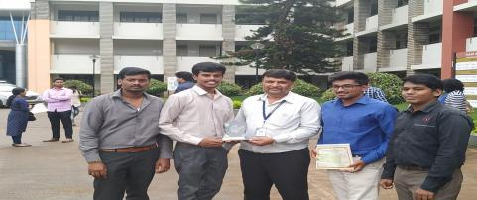

Students of 8th semAJEYA.V, DAYANANDA M, MADAN KUMAR L, ANIRUDH R K participated in KSCST state level project exhibition held at KLE Society’s Dr.M.S. Sheshagiri College of Engineering and Technology, Belagavi on 26th and 27th July 2019. The project titled “Evaluation of Biofuel blended with prepared ethanol, N-Butanol& petrol based on performance & pollution level tests on an SI engine” was guided by Professor RaghuthoamRao

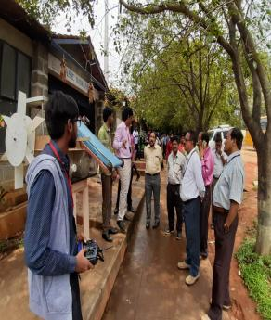

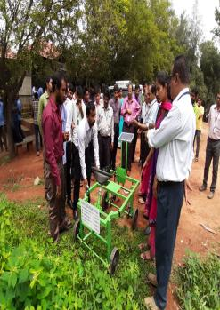

PROJECT EXHIBITION IN THE DEPARTMENT

Final year students’ project exhibition was held on June 7th 2019 between 10 am to 1pm. Around 32 batches of students participated and demonstrated their projects. The projects were well designed and fabricated to address the issues related to Agricultural issues, Performance analysis of I.C.Engines, Power generation through alternate source of energy, Non-conventional energy sources etc. The project exhibition was well received by the students of other semester and branches and was appreciated by the faculties and heads of departments of other branches.

**EDITORIAL TEAM**

**CHIEF EDITOR:Dr.P.MahadevaSwamy**

**SUB EDITOR: Prof.Prathima C N**

**Student Members:Goutham B S(5thsem)**